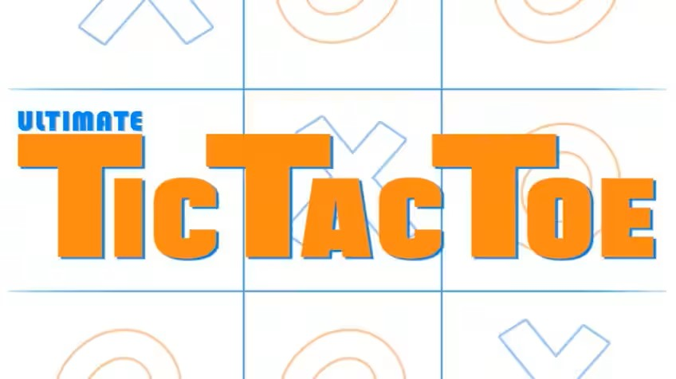

**PROJECT REPORT:** TIC TAC TOE

**SUBMITTED TO:**

Mohammad Shahin Uddin

Adjunct Faculty

Department of CSE,IIUC.

**SUBMITTED BY:**

~ MARUF KHAN (C231226)

~ RAFID SAYEED BIN FAROOK (C231209)

* **INTRODUCTION**

The Tic-Tac-Toe Game project aims to implement a classic two-player game with a user-friendly interface. Tic-Tac-Toe, also known as noughts and crosses, is a simple yet engaging game that serves as an excellent introduction to programming and game development. The project focuses on creating a playable and interactive version of Tic-Tac-Toe with features like user input validation and a visually appealing interface.

* **COMPONENTS**

1. User Interface: Manages the visual representation of the game grid and user interactions.
2. Game Logic: Implements the rules of Tic-Tac-Toe, validates moves, and checks for a winning condition.
3. Input Handling: Receives and processes user input, ensuring it is within the valid range of moves.
4. Outcome Display: Displays the result of the game (win, lose, or draw).

* **DESCRIPTION**

Move of player 1 or ‘ X ’

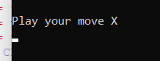

Move of player 2 or ‘ 0 ’

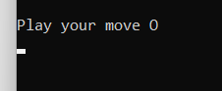

When three of the moves of the same player makes a straight line ,he wins.

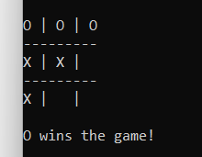

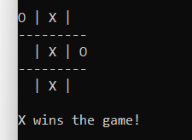

When none can make a straight line with three blocks, that’s a draw.

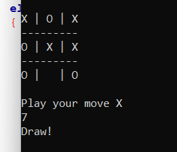

* **MAJOR TASKS**

The development of the Tic-Tac-Toe Game involves several major tasks:

1. User Interface Design:

Designing a graphical representation of the 3x3 grid.

Creating an interactive interface for player moves.

1. Game Logic Implementation:

Developing algorithms to check for winning conditions.

Handling player turns and ensuring valid moves.

Implementing the game loop to allow continuous play.

1. Input Handling:

Accepting user input for X and O positions on the grid.

Validating input to prevent illegal moves.

1. Outcome Display:

Determining and displaying the game outcome (win, lose, or draw).

* **SOURCE CODE**

https://controlc.com/6a187efd?fbclid=IwAR2Lq_lZEd7xhq-qyV1b_CDB3Qhsr9kT1cjeSVNvfp118iio0XDa6Xr6jdM

* **FUTURE SCOPE**

Add some graphics and many more..

* **CONCLUSION**

In conclusion, the Tic-Tac-Toe Game project successfully implements a classic game with a user-friendly interface. The project demonstrates fundamental concepts in programming, such as user input handling, game logic implementation, and graphical interface design. The completion of this project enhances understanding and skills in software development and lays a foundation for tackling more complex game development projects. Tic-Tac-Toe remains a timeless and educational game, serving as an ideal starting point for aspiring programmers and game developers.